Demographic Analysis

Craig O'Neill and Elizabeth Chen

February 28, 2018

devtools::install_github("brucekendall/PVA")

library(PVA)  
library(tidyverse)  
library(popbio)  
library(primer)

## Step 1 Create Demographic Matrix

For the demographic matrix I am using a pre-breeding survey. The three stages that I am using are Tadpoles, Subadult, and Adult. Due to the semi-recent reclassification of the Yosemite population of the Yellow-Legged Frogs into it's own distinct species, some of my data comes from studies done on Mountain Yellow-Legged Frogs (R. muscosa) rather than the Sierrian Yellow-Legged Frogs (R. Sierran).

The tadpole stage is includes the egg stage in the lifecycle (since the egg stage is very short). Subadults include recently metamorphed tadpoles, up until the frog reaches breeding size at approximately 40mm svl (snout/vent length). Adults reach maturity after approximately 1-2 years after metamorphosis (Bonham, 2011).

Studies have shown that a significantly large portion (99-98%) of fertilized eggs hatch into tadpoles after 18-20 days (Vrendenburg, Fellers, & Davidson, 2005). Tadpole metamorphosis occurs between 1-2.5 years, or 2-3 overwinters (Vrendenburg, Fellers, & Davidson, 2005). I was not able to find specific data regarding the probability of whether tadpoles metamorphosis occurs after Year 1, or Year 2, however it appears from literature for higher elevation Mountain Yellow Legged Frogs (ie the population of interest in Yosemite National Park) they tend to take 2 years.

Survivorship of tadpoles into Subadults is relatively low. I could not find specific numbers for the Mountain Yellow-Legged Frogs, however found studies indicating that approximately 1-5% of tadpoles survive metamorphisis and become subadults across a variety of frog species (Calef, 1973). For this analysis, I am assuming the lowest survivalship rate of 1% for all tadpoles to reach the subadult life stage. Since observations of the species have observed that higher elevation Mountain Yellow Legged Frogs typically spend 2 years as tadpoles, I am presuming that only 0.1% of 1 year old tadpoles become subadults in year 2 and survive. The probability for a tadpole in year 1 to survive and become a year 2 tadpole is presumed to be 9.5%. This creates a cumulative survivorship for tadpoles to subadults to be the probability of Tadpole1 becoming Subadult1 (0.001) plus the probability of a tadpole in year 1 remaining a tadpole in year 2 (0.095) multiplied by the probability of a tadpole in year 2 survining and becoming a subadult (0.095) which equals 0.01, or 1% of tadpoles reach the lifestage of a subadult (Figure).

Subadult frogs typically progress into breeding adults after 1 year, however some may remain as subadults for a second year. I could not find any studies that clearly determined what proportion of subadults remain as subadults for a multiple year, but I have assumed it to be very small (10%). Mortallity of subadults is also very high, with only approximately 20% reaching the adult stage (Bonham, 2011), this is likely due to how metabollically expensive it is for the tadpole to complete metamorphisis, and the risk associated with being a smaller frog.

Adults, in comparison, have been found to have fairly high estimates. One assessment claims that over 90% of adults survive year to year, with other estimates suggesting between 56% and 86% (Bonham, 2011) (Briggs, Knapp, & Vredenburg, 2010). For this project I took an estimated median value of 70%.

Reproduction only occurs in the adult stage. Breeding occurs within a distinct seasonal time period and female frogs only lay one egg mass per year. Eggmasses on average contain 150 to 300 eggs (Nafis, 2018). For this assessment I have assumed that 225 eggs on average are laid.

Breeding is constrained by the number of available females, so therefore this demographic analysis will only be looking at female population numbers. The sex ratio for this frog has been observed as 1:1 (Bonham, 2011), and I have found no indication that environmental factors contribute to whether or not an egg is female or not, so therefore I have assumed that half of the laid eggs will be female (112). A personal conversation with a herpatologist confirmed that for this species that would be a decent enough estimation (E., Wilson, Personal Conversation on February 26, 2018).

### Demographic Matrices

|  |  |  |  |  |  |
| --- | --- | --- | --- | --- | --- |
|  | **Tadpole1** | **Tadpole2** | **Subadult1** | **Subadult2** | **Adult** |
| **Tadpole1** |  | 0 | PjPgF1 | PjPgF1 | PaF1 |
| **Tadpole2** | Pt | 0 | 0 | 0 | 0 |
| **Subadult1** | PtPs | PtPs | 0 | 0 | 0 |
| **Subdault2** | 0 | 0 | Pj | 0 | 0 |
| **Adult** | 0 | 0 | PjPg | PjPg | Pa |

Pt : Probability of a Tadpole surviving a year and remaining a tadpole

Ps: Probability of a tadpole becoming a subadult

Pj: Probability of a subadult surviving a year

Pg: Probability of a subadult becoming an adult

Pa: Probability of an adult surviving

F:

Where:

P0 = 1

P1 = 0.01

P2 = 0.2

P3 = 0.7

G0 = 0.4

G1 = 0.2

G2 = 0.75

F1 = 150

|  |  |  |  |
| --- | --- | --- | --- |
|  | **Tadpole** | **SubAdult** | **Adult** |
| **Tadpole** | 0.6 | 0 | 16.128 |
| **Subadult** | 0.004 | 0.25 | 0 |
| **Adult** | 0 | 0.15 | 0.7 |

## Demographic Diagram

Attached is my filled out DemographicDiagram. I included my math and working through the diagram to solve for R0 (though some assumptions, such as adult survivorship, changed between writing this final demographic analysis and when I did this by hand).

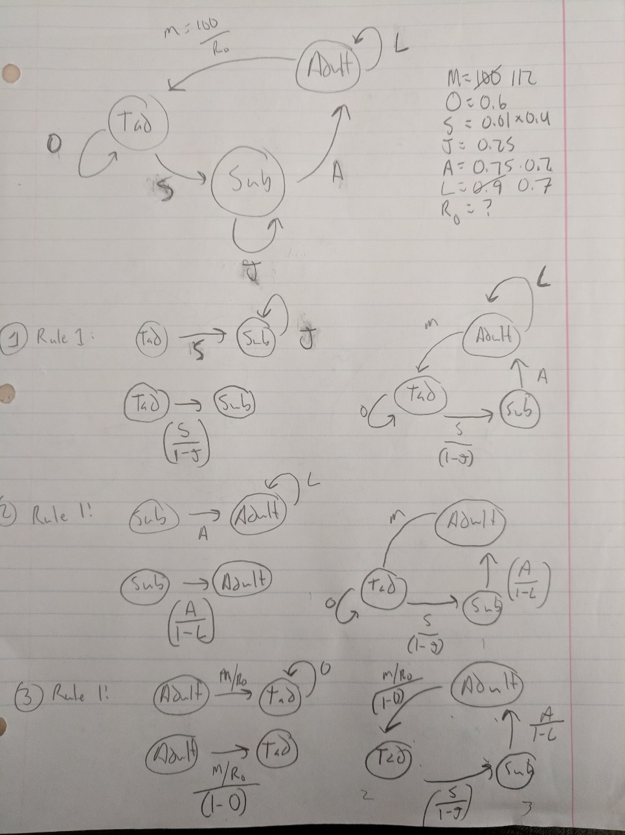

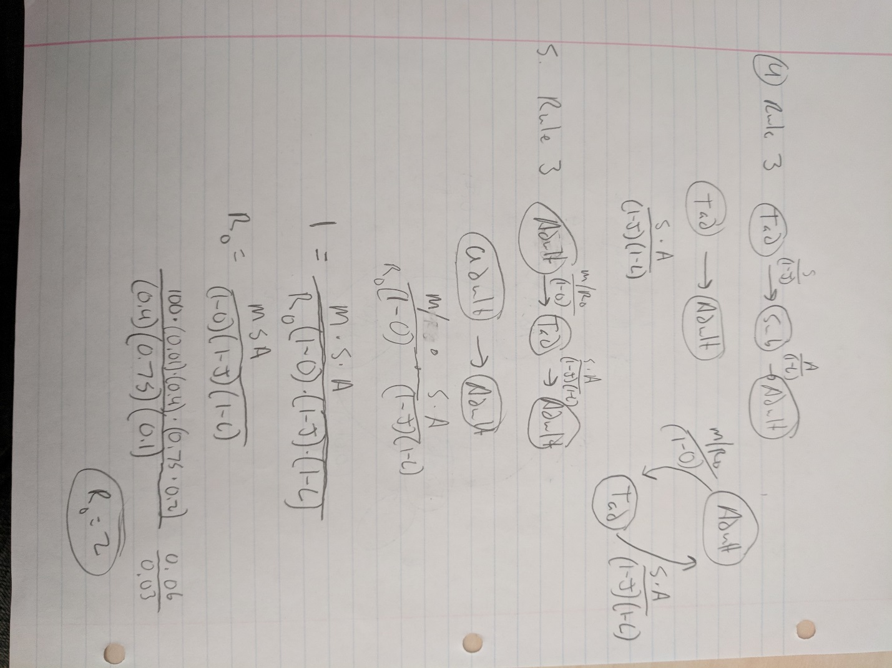

# Scripting and Demographic Analysis

class_names <- c("Tadpole", "Subadult", "Adult")  
A <- matrix(c(0.6, 0, 16.128,  
 0.004, 0.25, 0,  
 0, 0.15, 0.70),  
 nrow = 3, ncol = 3, byrow = TRUE, dimnames = list(class_names, class_names))

The model we are using is pre-breeding. All subadults must first mature into adults before breeding can occur.

Due to time constraints this week, I used population count data from Survey Site 1764 to analyze the population demographics for the frog. This lake is the most surveyed lakes (55 surveys over 20 years) (Knapp, et al., 2016). Following Knapp's methodology to account for multiple surveys within the same year for a single lake I averaged the population counts. To build this model I set the starting population equal to the average abundance in the final year of the survey.

n_0 <- c(278, 297, 2682)  
time <- 10  
  
pop <- pop.projection(A, n_0, iterations = time)  
pop

## $lambda  
## [1] 0.7956404  
##   
## $stable.stage  
## Tadpole Subadult Adult   
## 0.98102745 0.00716303 0.01180952   
##   
## $stage.vectors  
## 0 1 2 3 4 5  
## Tadpole 278 43422.096 57050.4672 56110.6428 49448.4053 41384.9643  
## Subadult 297 75.362 192.5289 276.3341 293.5261 271.1751  
## Adult 2682 1921.950 1356.6693 978.5478 726.4336 552.5324  
## 6 7 8 9  
## Tadpole 33742.2217 27139.2301 21673.7468 17245.0311  
## Subadult 233.3336 193.3023 156.8825 125.9156  
## Adult 427.4490 334.2143 262.9454 207.5941  
##   
## $pop.sizes  
## [1] 3257.00 45419.41 58599.67 57365.52 50468.36 42208.67 34403.00  
## [8] 27666.75 22093.57 17578.54  
##   
## $pop.changes  
## [1] 13.9451667 1.2901900 0.9789395 0.8797682 0.8363392 0.8150696  
## [7] 0.8041957 0.7985606 0.7956404

stage.vector.plot(pop$stage.vector)

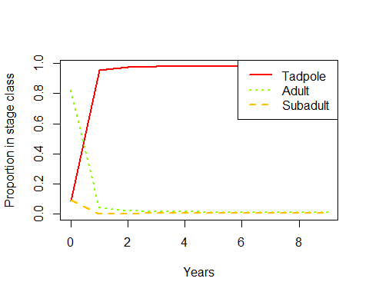

stage.vector.plot(pop$stage.vector, log = "y")

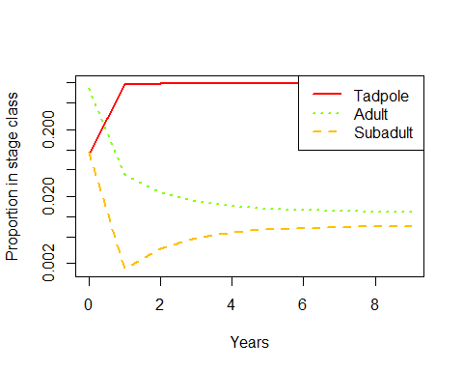

## Sensitivity and Elasticity

S <- DemoInfo(A)  
S

## $lambda  
## [1] 0.792598  
##   
## $SSD  
## [1] 0.981052173 0.007232258 0.011715570  
##   
## $RV  
## [1] 1.00000 48.14951 174.17218  
##   
## $Sensitivities  
## [,1] [,2] [,3]  
## [1,] 0.29113 0.002146193 0.003476628  
## [2,] 14.01776 0.103338118 0.167397929  
## [3,] 50.70674 0.373807058 0.605531905  
##   
## $Elasticities  
## Tadpole Subadult Adult  
## Tadpole 0.22038660 0.00000000 0.07074337  
## Subadult 0.07074337 0.03259474 0.00000000  
## Adult 0.00000000 0.07074337 0.53478853  
##   
## $PPM  
## Tadpole Subadult Adult  
## Tadpole 0.600 0.00 16.128  
## Subadult 0.004 0.25 0.000  
## Adult 0.000 0.15 0.700

The asymptomatic growth rate for this species is showing decline, with a lambda of less than 1.

According to our sensitivity analysis, the most sensitive life stage for the frogs exist for tadpoles becoming subadults. Putting in management efforts to increase survivorship of this transition would have the greatest affect on the asymptomatic growth rate for the species.

However, when we looked at the proportional effect that increasing survivorship has on increasing the asymptomatic growth rate using an elasticity analysis has shown that increasing adult survivor ship will have the greatest impact. My assumption of this related to the biology of the species: The number of eggs and tadpoles produced by each adult female, and the extreme levels of tadpole mortality, increasing the the number of breeding adults would have the greatest effect.

## Investigating Sensitivity and Elasticity of Lambda to Vital Rates

1. Recreate the matrix symbolically

A.vr <- expression((1-g0), 0, (p2*g2*f1),  
 (p0*g0), (p2*(1-g1)), 0,  
 0, (p2*g2), p3)  
  
  
p <- c(1, 0.01, 0.2, 0.7)  
g <- c(0.4, 0.2, 0.75)  
f <- c(0, 0, 112)  
  
vr.vals <- list(p0 = p[1], p1 = p[2], p2 = p[3], p3 = p[4],  
 g0 = g[1], g1 = g[2], g2 = g[3],  
 f1 = f[3])  
  
vitalsens(A.vr, vr.vals)

## estimate sensitivity elasticity  
## p0 1.00 0.326745902 0.215787230  
## p1 0.01 0.000000000 0.000000000  
## p2 0.20 3.460485116 0.457069848  
## p3 0.70 0.401307135 0.185519905  
## g0 0.40 0.459454508 0.121371886  
## g1 0.20 -0.048256523 -0.006373847  
## g2 0.75 0.871322406 0.431574461  
## f1 112.00 0.002917374 0.215787230

From this analysis I can see that the greatest impact is shown in increasing the annual survivorship of subadults both in absolute (sensitivity) and proportional effort (elasticity). This indicates that if I can get more subadults to survive, I would have the greatest increase in the asymptomatic growth rate.

## Things missing from this model

The obvious lack of data regarding lifestage survivorship and growth rates for the frog, which could drastically affect the asymptomatic growth rates and conclusions I have drawn from this analysis. Considering the dataset that I am basing this project on has shown an overall increase in population size for the frogs in Yosemite National Park, yet my demographic analysis is indicating a decrease in asymptomatic growth rates shows that something is wrong in my assumptions.

Another missing aspect of this model is that the model is not taking into account any form of density dependence. From studying the ecology of the frog I can infer that this is a potentially huge failing, as the frogs will spatially distribute themselves along the shore of the lake to mark out preferential breeding territory. At a certain point there would be too many frogs and not enough lake for them all to live in.

Environmental stochasticity is missing from this model, which greatly impacts the frog's development and survival. Multiple "good" years could create a natural scenario where subadult survivorship grows, drastically increasing lambda for the population. Environmental stochasiticity is most likely to impact the early life stages which would be particularly vulnerable to increased streamflow (which may cause increased mortallity to eggs or tadpoles due to eggmasses being scoured from the lakes or streams, though my population is in a lake so probably not that big of a deal). Extreme cold winters would likely affect all populations equally if the cold weather is able to freeze the lake solid, preventing the frogs of all life stages from finding and hibernating in the refuge beneath the lake.

# References

Bonham, C. (2011). *A Status Review of the Mountain Yellow-Legged Frog (Rana sierrae and Rana muscosa).* State of California, Department of Fish and Game. Natural Resources Agency.

Briggs, C. J., Knapp, R. A., & Vredenburg, V. T. (2010, May 25). Enzootic and epizootic dynamics of the chytrid fungal pathogen of amphibians. *PNAS, 107*(21), 9695-9700.

Calef, G. W. (1973, July 1). Natural Mortality of Tadpoles in a Population of Rana Aurora. *Ecology, 54*(4), 741-758.

E., Wilson, Personal Conversation on February 26, 2018. (n.d.).

Knapp, R. A., Fellers, G. M., Kleeman, P. M., Miller, D. A., Vredenburg, V. T., Rosenblum, E., & Briggs, C. J. (2016, October). Large-scale recovery of an endangered amphibian despite ongoing exposure to multiple stressors. *Proceedings of National Academy of Sciences, 42*(113), 11889 - 11894.

Nafis, G. (2018). *Sierra Nevada Yellow-legged Frog - Rana sierrae*. Retrieved from CaliforniaHerps.com: http://www.californiaherps.com/frogs/pages/r.sierrae.html

Vrendenburg, V. T., Fellers, G. M., & Davidson, C. (2005). The mountain yellow-legged frog (Rana muscosa). In *Status and Conservation of U.S. Amphibians* (pp. 563-566). Berkeley, California: University of California Press.